**Report about conducted load test**

**Date:** 17/05/2022

**Author:** Vladyslav Kliucharov

**Application:** BlogEngine.NET version 3.2

**Environment:** Test Environment VirtualBox (Version 6.1.34 r150636 (Qt5.6.2))

**Test Environment configuration(RAM, CPU etc.):**

|  |  |
| --- | --- |
| **Processor** | 11th Gen Intel(R) Core(TM) i7-1185G7 @ 3.00GHz 3.00 GHz (4 core) |
| **RAM** | 8 GB |
| **Hard Disk** | 60 GB |
| **Operating System** | Windows 10 Enterprise (21H2) |

1. **Why such testing was conducted:**

The report is included two methods of testing:

1. Smoke testing - was conducted to verification that the crucial functions of a program can be run and executed in the main workflow

2. Capacity Testing - was conducted to define the number of users that the application a given system will support and still meet performance goals

1. **Test script description:**

The features to be tested have been logically grouped to be covered 3 scripts that were developed followed by load requirement analysis for the modules. The below table captures the features covered by each script

|  |  |  |
| --- | --- | --- |
|  |  |  |

1. **Tests:**  
   **Test run preconditions:**

* CSV file with Random dates
* Warmup script was running before each test run
* Before each new test script run, the webserver was reloaded, the test executed in NON-GUI mode  
  **Load Model:**

|  |  |  |  |  |
| --- | --- | --- | --- | --- |
| **Test Name** | **Maximum number of simultaneous users** | **Ramp-Up period** | **Test duration** | **Probabilities usage** |
| Blog_Post_Anonimus_Task3 | 100 | 600 | 600 (sec.) | Random |
| Blog_Post_Anonimus_Task6 | 100 | 600 | 600 (sec.) | Pre-Defined |

1. **Short summary on conducted tests:**

Capacity testing results showed below in the table, according to the testing results user's capacity and throughput (max/ops) pre-define probabilities are show growing by 22%

|  |  |  |
| --- | --- | --- |
| **Test Name** | Users Capacity | Capacity Throughput (max/ops) |
| Blog_Post_Anonimus_Task3 | 49 | 48 |
| Blog_Post_Anonimus_Task6 | 60 | 96 |

1. **Detailed test results:**

The Blog_Post_Anonimus_Task6 script was running 3 times, according to the capacity testing result, the comfort zone prior to 54 users, and the saturation point is approximately 55 users. Degradation of successful queries is start between 55-57 users. After reaching a user’s capacity of 57-57 users, the server CPU is grooving to 100%.

**Test Run #1**

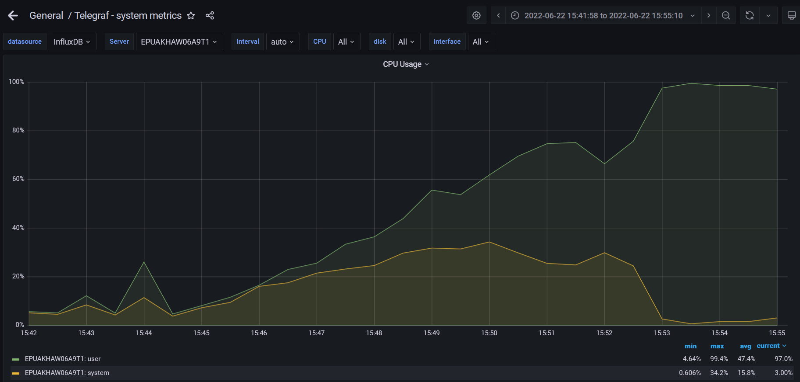

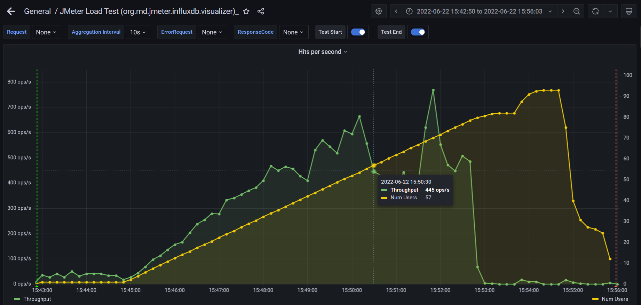

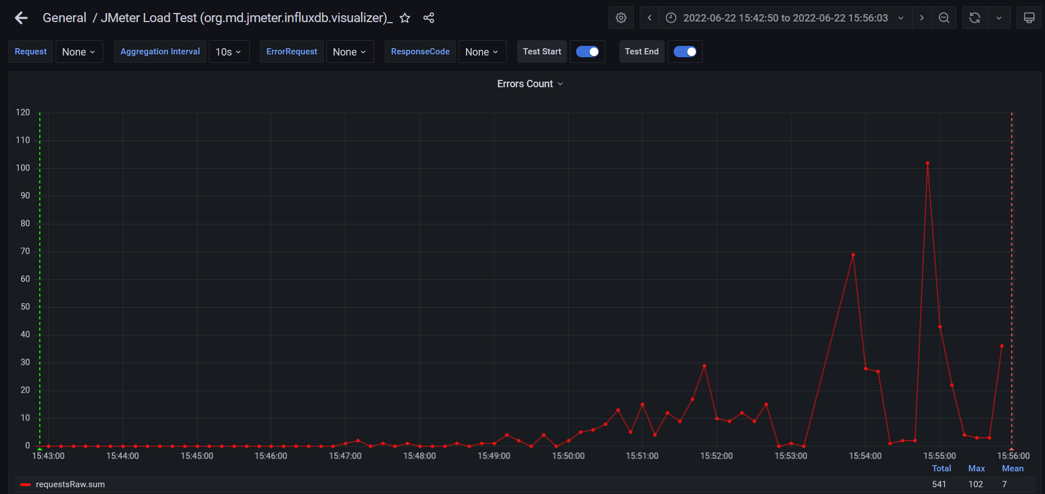

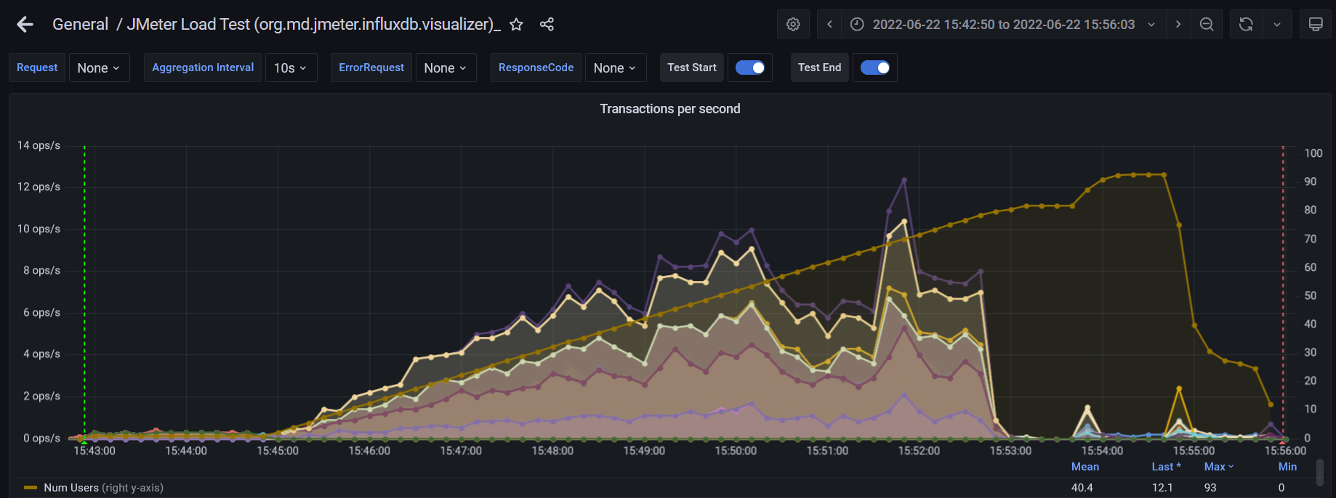

**Test Run #2**

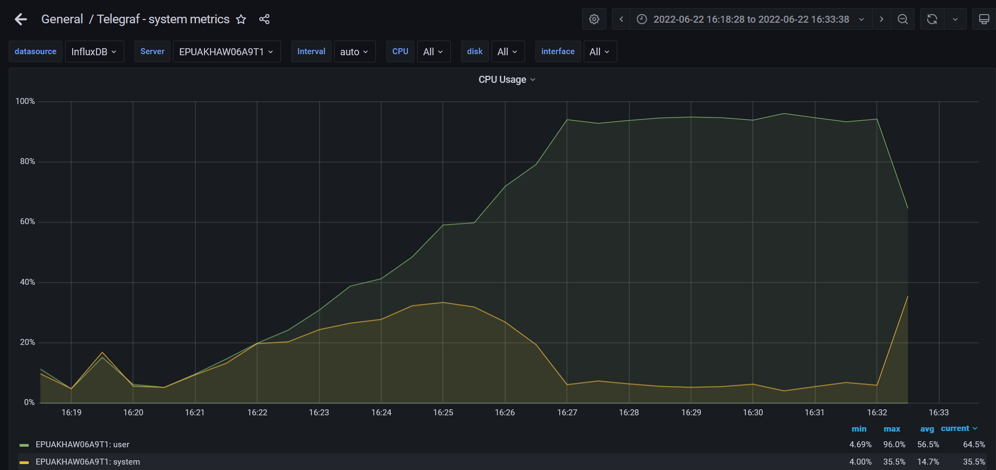

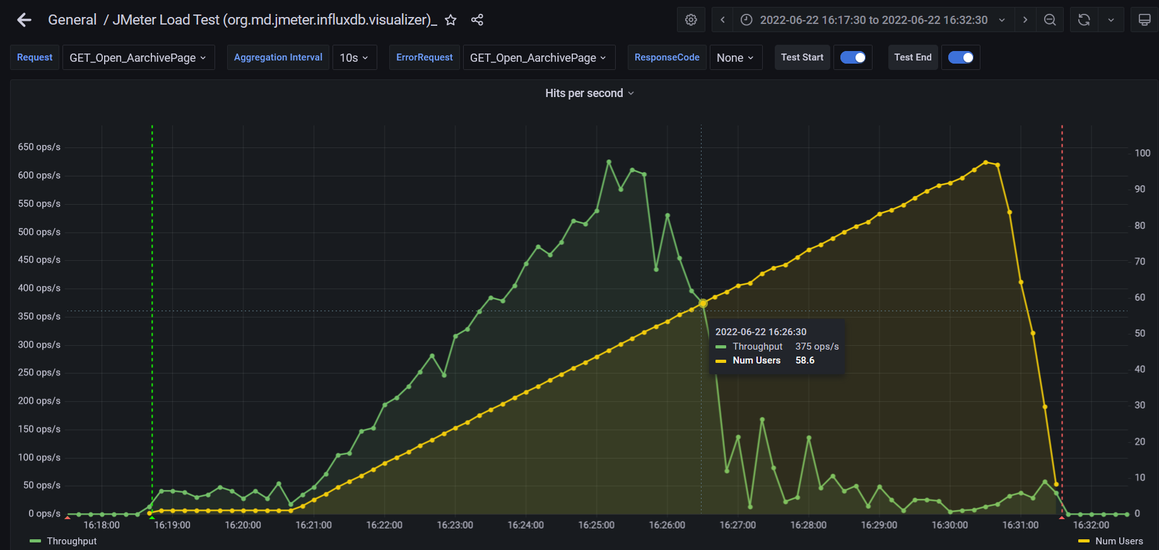

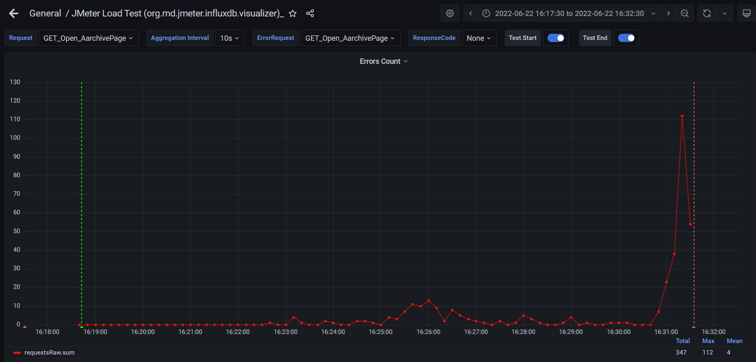

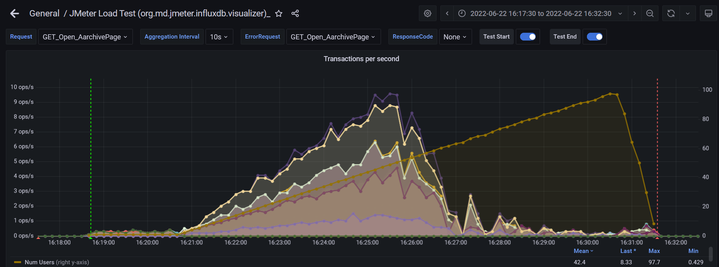

**Test Run #3**

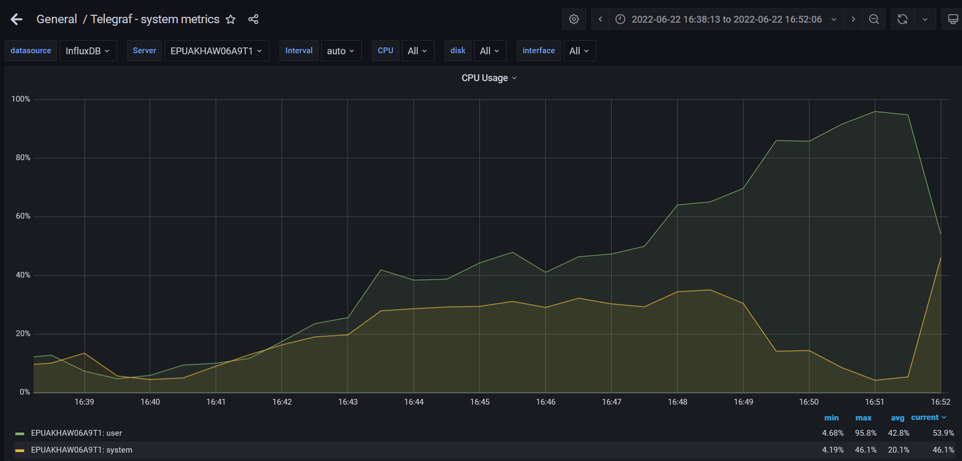

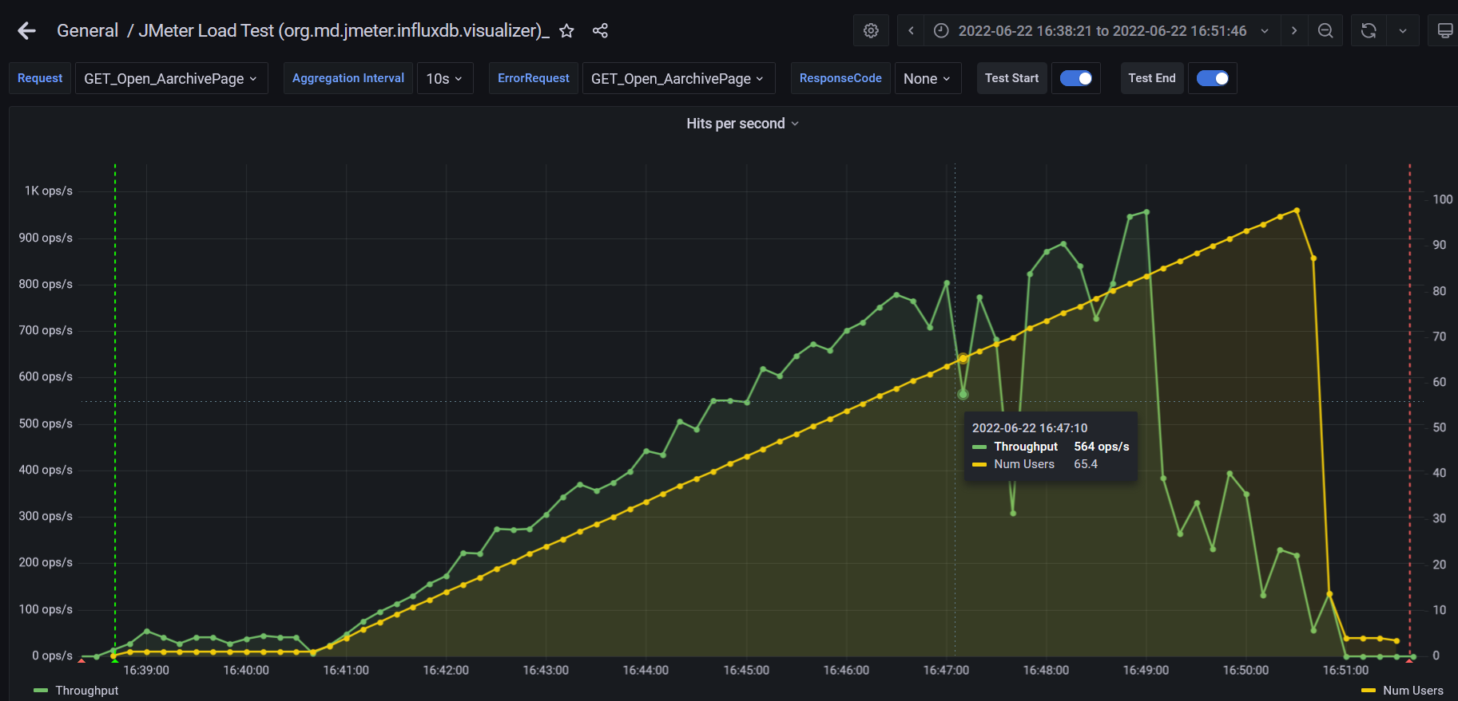

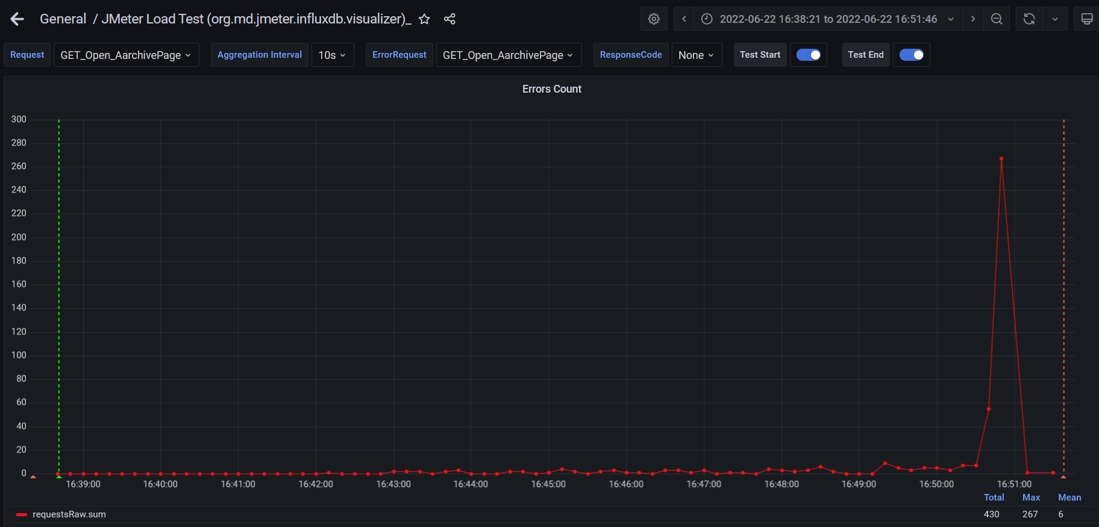

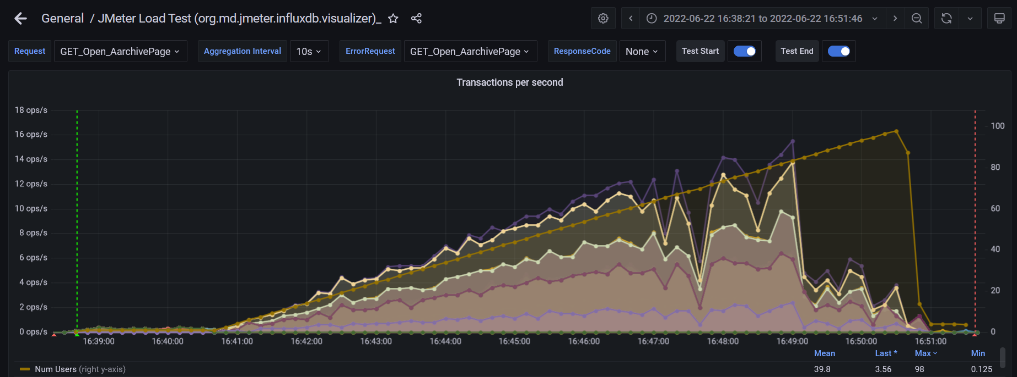

1. **Conclusion:**

The result was received by comparing of test results, which are shown on the graphics and table value (view above).

The 5XX – errors were not found.

The 404 - errors are approximately 1-2%.

The main error was “Non-HTTP response code: java.net.SocketTimeoutException/Non HTTP response message: Read timed out” which down the user's possibility of sending the new requests on the server. After saturation point, the number of errors was grown, and the CPU has been risen to 100% as a consequence response time from the server was growing up too that exceeding 60 seconds.